**Adam Blake Bell**

**LFF734**

**ENEE 4710 Embedded Systems**

**Dr. Loveless**

**9/20/18**

**HOMEWORK #3**

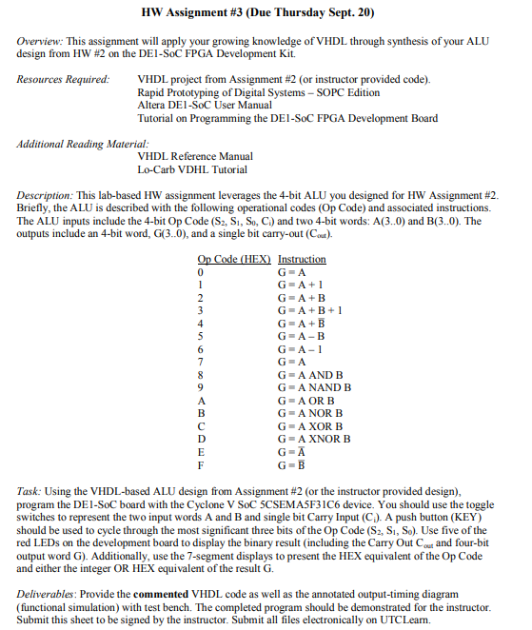

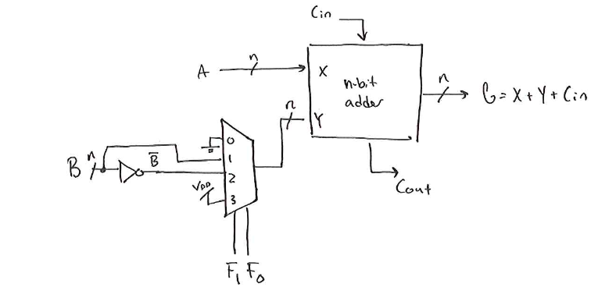

Figure 1 Arithmetic Unit of ALU

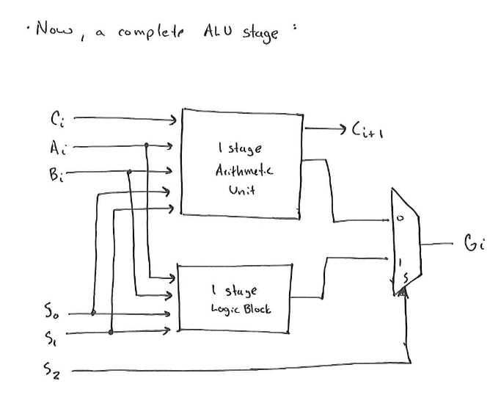

Figure 2 Full ALU architecture with Arithmetic and Logic Unit

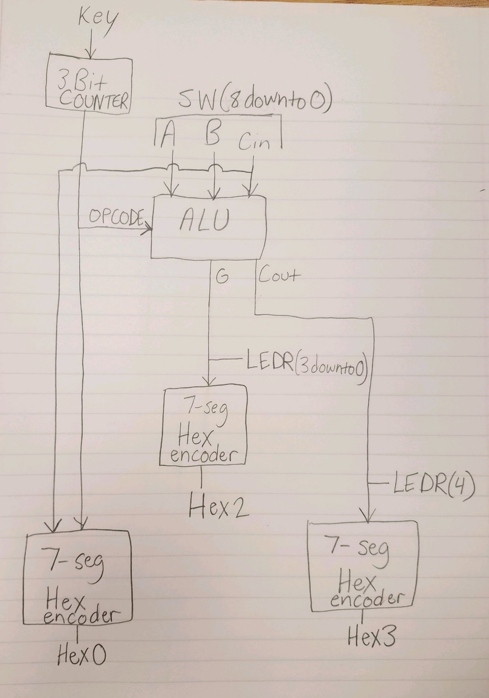

Figure 3 ALU with 3 bit counter used for S2 S1 S0 of the Opcode. The 3 bit counter allows use of a button to cycle through the operations. The inputs A, B, and Cin are controlled by 9 switches. Three 7-segment hex encoders are used to convert the binary signals of G, Cout, and OPCODE to Hex representations on three separate 7-segment displays. Cout and G can also be displayed in binary on LEDs using the output LEDR.

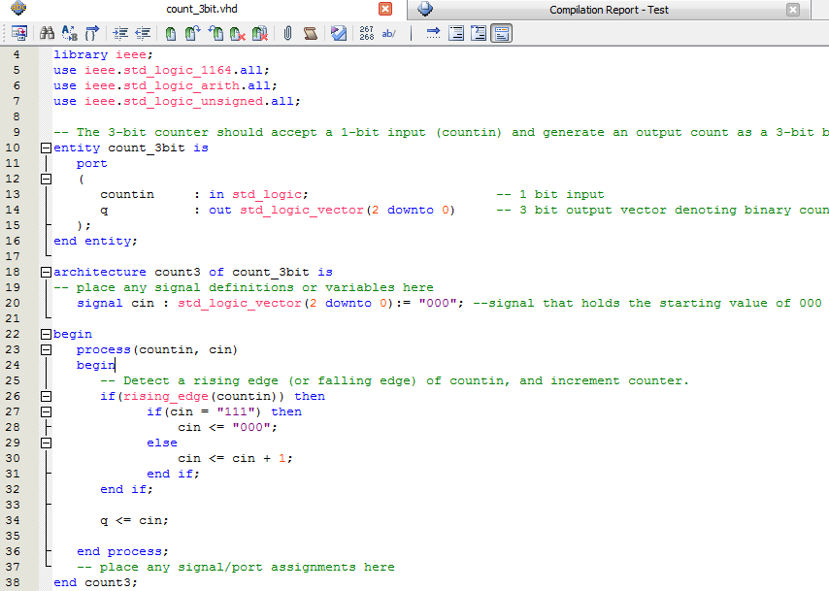

Code for my 3 bit counter. Starts at “000” and adds 1 when a rising clock edge of the input is sensed. Resets at “111”

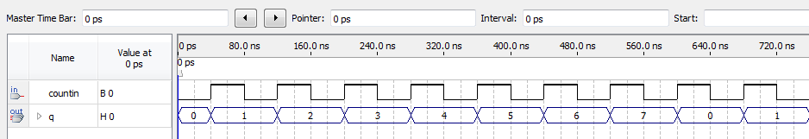

Functional Simulation shows that the counter can correctly count from 0 to 7 although it is actually using binary.

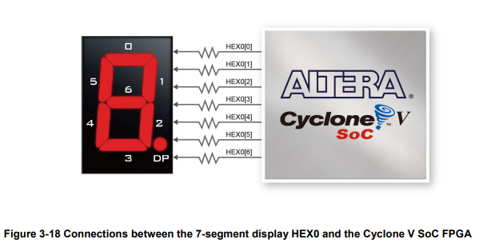

Figure 4 Diagram showing 7-segment display mappings. Taken from Altera DE1-SOC User Manual

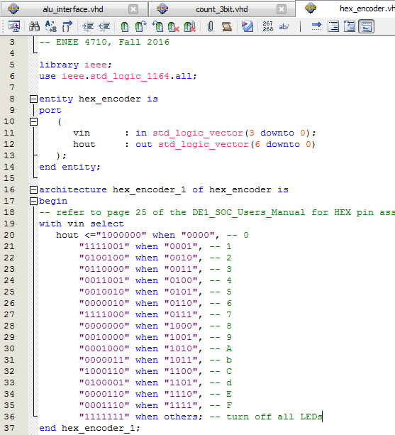

Figure 5 7-segment Hex encoder. Takes 4 bit binary and converts it to a HEX encoding to display equivalent HEX on a 7-segment display. The individual LEDs are off when the hout bits are HIGH.

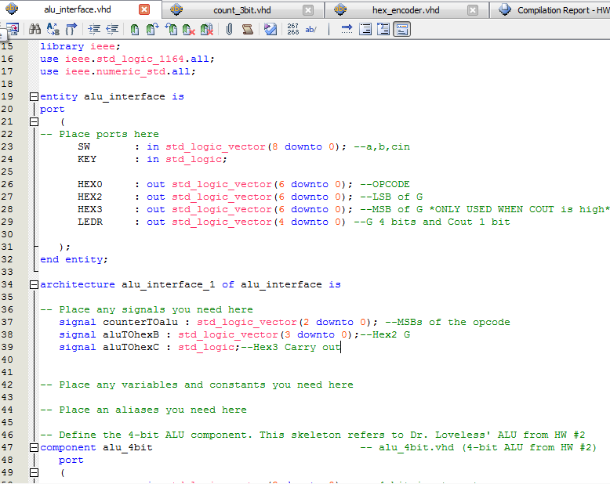

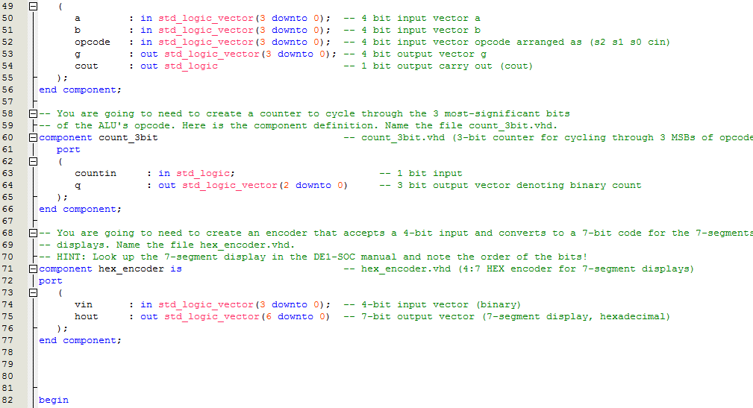

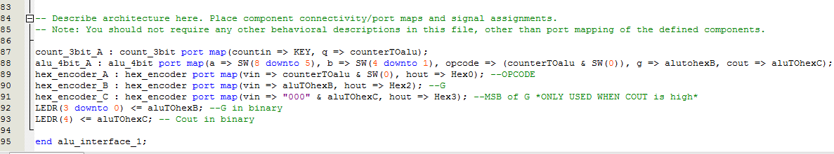

Figure 6 Code for my ALU interface which uses an ALU, 3 Hex encoders, and a 3 bit counter

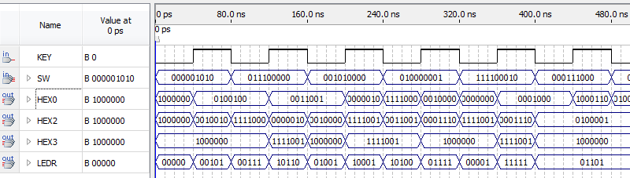

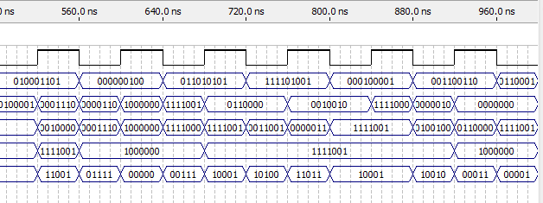

Figure 7 The functional simulation above shows the outputs of the hex encoding when random values are input into SW which is A, B, and C. The Functional Simulation is much less useful in this lab because it is time consuming to decipher the hex encodings. It is much easier to do testing on the board because the HEX outputs can be clearly red on the 7-segment displays.

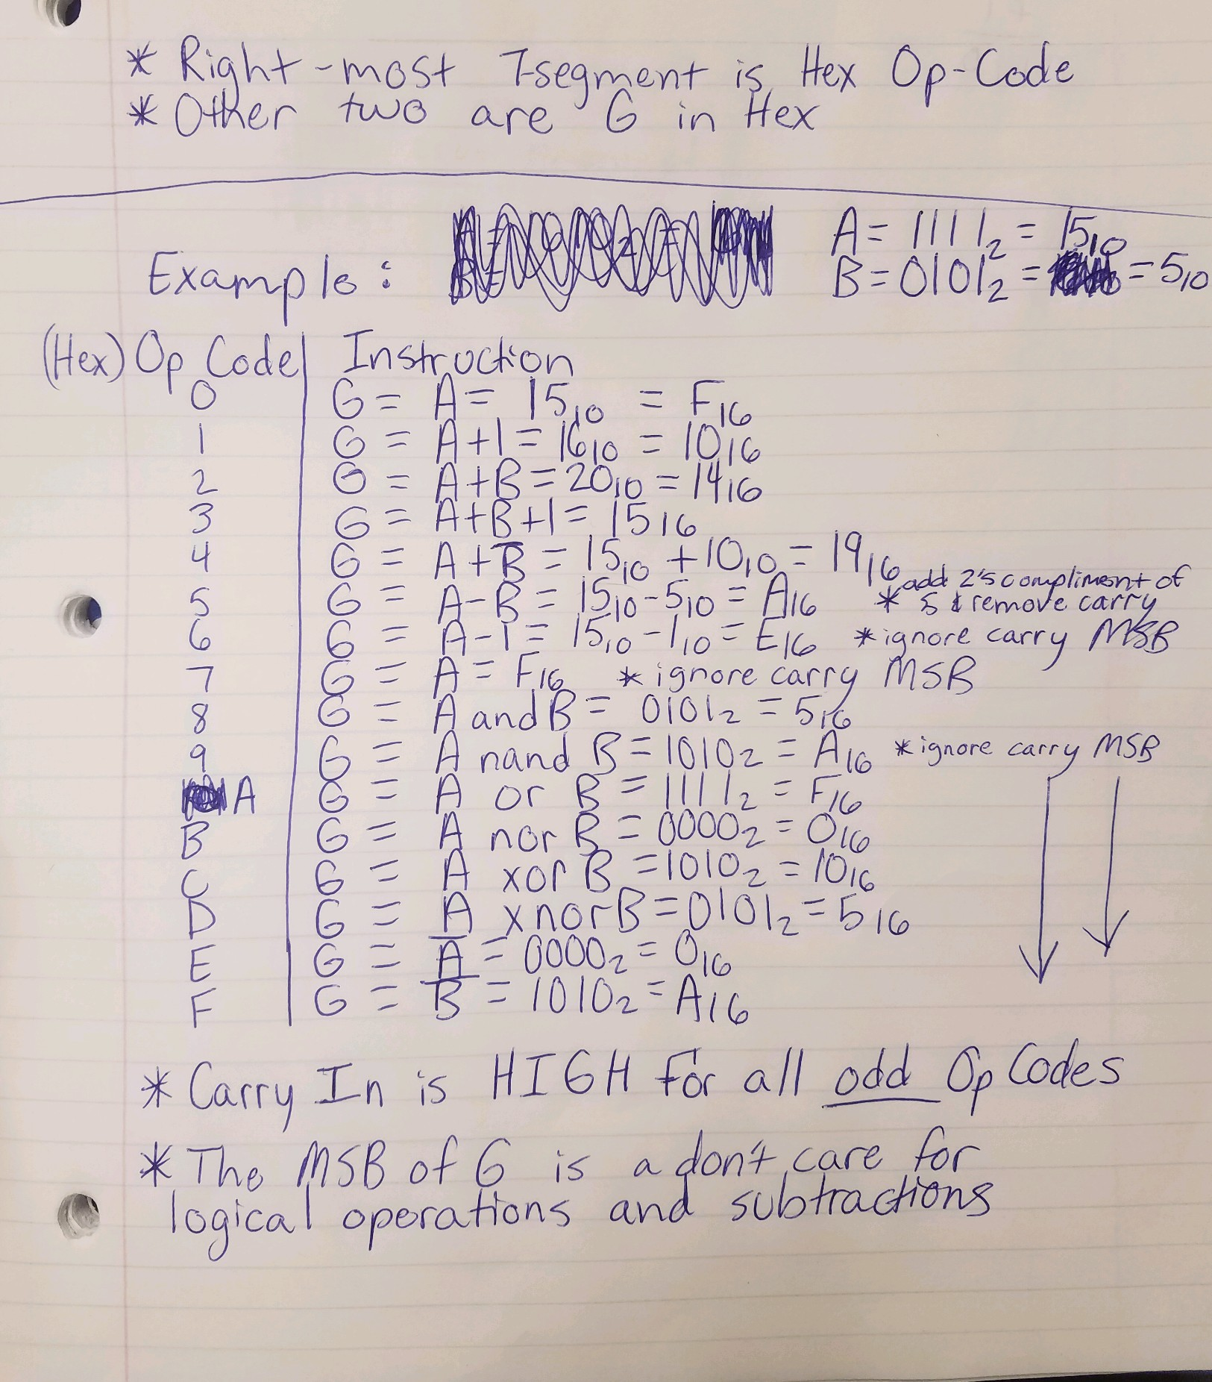

Figure 8 the above image shows the test cases I used for each Opcode to test the vhdl code on the FPGA board. The pictures below match the outputs expected. However in some instances of subtraction and logical operations, the Cout shows 1 on the 7-segment display. This can be ignored due to the nature of subtraction being the addition of 2’s compliment and unsigned binary and the outputs having M>N so the carry bit can be discarded. For logical operations the Carry Bit is not even used.

The right-most switch on the FPGA board is mapped to control Carry-In. The four switches to the left of that switch controls the input B and the four switches to the left of B control input A. The MSBs of A and B are on the left and are not inverted. The four right-most LEDs symbolize the output G in binary, while a single LED to the left of these LEDS symbolizes the Carry-out.

Three Hex 7-segment displays are used here. The right-most Hex bit represents the Opcode, and the left two displays represent Carry-out and G.

There are four buttons to the right of the switches. The right-most button changes the state of the binary counter adding 1 to the Opcode. The other buttons are left unwired.

